TITANIC SURVIVORS PREDICTION
Project Report
<Template Version 1.3>

Industrial Training & Presentation (ECS791)
Degree
BACHELOR OF TECHNOLOGY (CSE)

PROJECT GUIDE:  Ms. Rohaila Naaz | SUBMITTED BY:  Manish Gupta (TCA1709110)

September, 2020 – November, 2020



FACULTY OF ENGINEERING AND COMPUTING SCIENCES
TEERTHANKER MAHAVEER UNIVERSITY, MORADABAD

ACKNOWLEDGEMENT

I have taken many efforts in this project. However, it could not be feasible without the kind help and assistance of many people and groups. I would like to extend my honest gratitude to all of them.
I am distinctly indebted to Ms. Rohaila Naaz for her steering and regular supervision in addition to for the presenting necessary statistics concerning the assignment and also for her aid in finishing the project.
I would love to specify my gratitude closer to my parents & members of Faculty of Engineering and Computing Sciences (FOECS), Teerthanker Mahaveer University for their kind co-operation and encouragement which helped me to complete this challenge.
I would really like to specify my unique gratitude and way to enterprise teachers for giving me such attention and time.
My thanking and appreciations additionally attend my colleagues in suggesting the task and folks who have volitionally helped me out with their skills.

Manish Gupta

Place: Teerthanker Mahaveer University, Moradabad
Date: 08/09/2020

DECLARATION

I hereby declare that this Project Report titled “TITANIC SURVIVORS PREDICTION” submitted by me and approved by our project guide, to the Faculty of Engineering and Computing Sciences (FOECS), Teerthanker Mahaveer University, Moradabad, is a bonafide work undertaken by me and it is not submitted to any other University or Institution for the award of any degree diploma / certificate or published any time before.

Student Name: | Manish Gupta | Signature
Project Guide: (External) | Name | Signature
Project Guide: (Internal) | Ms. Rohaila Naaz | Signature

Brief About the Company

The institute/organization from where I have completed my training is Internshala Trainings.

Internshala is a renowned internship and online training platform, based out of Gurgaon, India. Founded by Sarvesh Agrawal, an IIT Madras alumnus, in 2010, the website helps students find internships with organisations in India.

The platform, which was founded in 2010, started out as a WordPress blog that aggregated internships across India and articles on education, technology and skill gap. Internshala launched its online trainings in 2014. As of 2018, the platform had 3.5 million students and 80,000 companies.

Scholiverse Educare Private Limited (Internhala)'s Corporate Identification Number (CIN) is U80901HR2011PTC064443 and its registration number is 64443.

Organizational Address: Scholiverse Educare Pvt. Ltd. B-610, Unitech Business Zone, Nirvana Country, South City 2, Gurgaon, India – 122018.


Table of Contents
1 Project Title 6
2 Problem Statement 6
3 Project Description 6
3.1 Scope of the Work 7
3.2 Project Modules 7
3.3 Context Diagram (High Level) 7
4 Implementation Methodology 8
5 Technologies to be used 8
5.1 Software Platform 8
5.2 Hardware Platform 8
5.3 Tools 8
6 Advantages of this Project 9
7 Assumptions, if any 9
8 Future Scope and further enhancement of the Project 9
9 Project Repository Location 10
10 Definitions, Acronyms, and Abbreviations 10
11 Conclusion 11
12 References 11

Appendix
A: Data Flow Diagrams
B: Data Dictionary
C: Screenshots

Project Title

Titanic Survivors Prediction – Machine Learning

Problem Statement

The sinking of the Titanic is one among the foremost infamous shipwrecks in history. While there was some element of luck involved in surviving, it seems some groups of individuals were more likely to survive than others. In this project, my task as a Data Scientist is to build a predictive model that answers the question: “what sorts of people were more likely to survive?” using passenger data (ie name, age, gender, class , etc). The dataset used in this project can be obtained through Kaggle: https://www.kaggle.com/c/titanic

Machine Learning is the Art and Science of making the Machines Learn by themselves, it’s a systematic study of Computer Algorithms using Mathematical techniques like Statistics, Modeling and Computational Techniques like programming, it is a subset of Artificial Intelligence. Since we’re still in the phase of development of Narrow AI, ML is one of the hottest trends in Industry as of now and specialists are highly in demand by all Industries, it finds applications in Filtering, Computer Vision, and in NLP in the Linguistics, as Predictive Modelling in the Business Problems and Data Mining in such Industries. Machine Learning can be subdivided into 3 major categories, based on the type of problems the machine is solving and their nature, they are:
- Supervised Learning – Like Regression and Classification problems, Target Present
- Unsupervised Learning – Like Data Density and Clustering Problem, Untargeted
- Reinforcement Learning - Involving feedback based learning, out of experience
And, there are mixed types of learning problems that can be made out of the basic three one’s as mentioned above, however, these are most important one’s out there and the one’s that are most commonly used which form the basis of Machine Learning.

Project Description

This project is a simple yet powerful model that builds upon the basis of biggest maritime disasters in the history on the night of 15th of April, 1912 on Royal Mail Ship Titanic in which over 1500 people died and around 700 survived, the soul of the project is inspired from that incident and here, we’ve built a model to simply predict who will be the survivors of that incident which are traveling on RMS Titanic, we are provided with the Input Dataset containing details of all the Individuals on board and based on that, we are going to generate prediction dataset for the Survivors as the output of the Model in our Project. The domain of the Project is Machine Learning, however, since it being and extensive one, just going with Binary Classification problem (Supervised), here for now.

Scope of the Work

- Can be used cross platform any time subject to IDE availability as it’s an IPython Notebook.

- Can Predict Survivors of RMS Titanic with almost 72 percent accuracy in testing phase.

- The resultant predictions are almost instantly exported as another dataset by the model.

- However, unsuitable for Regression and Clustering Problems in the same domain.

- It is extensively used in the industry with manifestations as other business problems.

Project Modules

This Project runs on a Web Browser as an IPython ( Jupyter) Notebook which can be run on the Systems having the Anaconda IDE Installed, this Project’s notebook can then be successfully run on such machines on a Web Browser, calling the jupyter notebook command in CMD and importing the notebook thereby running the model with datasets.
In the Notebook, we can see the use of various Libraries as mentioned are being imported initially, then dataset is loaded an operations on it are performed as per ML Life Cycle and at the end, after building the model, the prediction dataset generated by the model can be seen being exported by the notebook.

Context Diagram (High Level)

PREDICTIONS
MODEL
DATA

Implementation Methodology

Please See Annexures

Technologies to be used

  - Software Platform
Libraries
- Pandas
- Numpy
- Matplotlib
- Scikit Learn

Back-end
- Python

  - Hardware Platform
- RAM : at least 4 GB of RAM
- Hard Disk : at least 5 GB of Disk Space on Hard Disk
- OS : Any Operating System
- IDE : Anaconda3 (4.3.1 x64) IDE – Python 3.6.0

  - Tools
Tool Name: IPython Notebooks (Jupyter Notebooks) by Anaconda (4.3.1 x64) IDE
Version: 4.3.1 x64 running on Python 3.6.0
Developer(s): Anaconda Inc. (Continuum Analytics Ltd.)
Written in: Python
Browser Used : Google Chrome (Recommended) or Mozilla Firefox

Advantages of this Project

- Can be used cross platform any time subject to IDE availability as it’s an IPython Notebook and can be enhanced by retraining model on same large dataset.

- Can Predict Survivors of RMS Titanic with almost 72 percent accuracy in testing phase.

- The Same model could be retrained for other similar problems of Binary Classification.

- The resultant predictions are almost instantly exported as another dataset by the model.

- It is extensively used in the industry with manifestations as other business problems.

- The Project doesn’t takes any user data or third party data apart from the input dataset for its usage, being concerned and inclined towards user or business privacy without denying user for accessing any feature of the Project.

Assumptions, if any

Basically, “Titanic Survivors Prediction” model needs a laptop or a desktop with the Anaconda IDE installed in prior to machine before running it along with the necessary data required to make predictions upon. Thus, the Model Notebook presumes to have a Machine with Anaconda IDE installed.

Future Scope and further enhancement of the Project

It is easier to extend the Model that we have developed to similar or other related variety of problems and Business Applications. We could enhance the train dataset or the entire dataset for that matter to provide a much more better model, which means our model could work smoothly on enormously large datasets with the similar problem i.e. Titanic Survivors Dataset to get better insights on doubtful data and could predict over forthcoming data using attributes learnt by this model. The same modelling procedure, the entire process along with the Algorithm can be also applied to other relevant and closely related Business Problems like the Financial Agents Prediction for a Sales Company, Predicting Defective Items in a Production Line, Credit Card Defaulters Prediction, Customer Churn Prediction for Financial Products like Savings Bank Account for a Bank etc. and so many more, the similarity being all are Binary Classification Problem and the model we created here suits the need and the best and the fastest Algorithm for such would be Logistic Regression, however, Ensemble Techniques are always recommended.

Project Repository Location

S# | Project Artifacts (softcopy) | Location  (Mention Lab-ID, Server ID, Folder Name etc.) | Verified by Project Guide | Verified by Lab In-Charge
 | Project Synopsis Report (Final Version) |  | Name and Signature | Name and Signature
 | Project Progress updates |  | Name and Signature | Name and Signature
 | Project Requirement specifications |  | Name and Signature | Name and Signature
 | Project Report (Final Version) |  | Name and Signature | Name and Signature
 | Test Repository |  | Name and Signature | Name and Signature
 | Any other document, give details |  | Name and Signature | Name and Signature

10 Definitions, Acronyms, and Abbreviations

Abbreviation | Description
DFD | Data Flow Diagram
IDE | Integrated Development Environment
OS | Operating system
RAM | Random Access Memory

Conclusion

The Titanic Survivors Prediction project developed is a Binary Classification Problem solved using Machine Learning Libraries of Python fully meets the objectives of the need for which it has been developed. The Model has reached a steady state where all possible identified and tested bugs have been eliminated. All sorts of Exploratory Analysis has been performed on the dataset prior to modelling and it was found that 342 passengers survived out of 891 on the ship, and the model was finally built using Logistic Regression Algorithm after rigorous testing using other techniques but LR was chosen as it performed better and was effective specific to this problem, finally I achieved approx. 74% accuracy on both train and test sets thus coming up as the Best Fitting Model, As so much as perfection is bothered no model is perfect ever and there square measure probabilities of improvement every moment. And, it could serve all similar variety of Binary Classification problems in the Industry provided it’s retained on new data.

References

a) Books
- Advanced Engineering Mathematics by Erwin Keyszig
- Higher Engineering Mathematics by BS Grewal and HK Das
- Linear Algebra by Gilbert Stang and Think Stats by Allen B Downey
- Software Engineering Principles and Practices by Roger Pressman

b) Websites
- www.google.com
- www.trainings.internshala.com
- www.youtube.com
- www.edx.com
- www.kaggle.com
- www.stackoverflow.com
- www.geeksforgeeks.com

S# | Reference Details | Owner | Version | Date
 | Project Synopsis | Manish Gupta | 1.0 | 03-12-20

Annexure A
Data Flow Diagram (DFD)

Zero Level Data Flow Diagram (DFD) is as follows:

PREDICTIONS
MODEL
DATA

One Level Data Flow Diagram (DFD) is as follows:
ALGORITHM
TRAIN

USER / BUSINESS
DATA

EVALUATION
TEST

PREDICTIONS
MODEL

Annexure B
Data Dictionary

Input Dataset
Variable | Definition | Key
PassengerId | Passenger ID
Survived | Survival | 0 = No, 1 = Yes
Pclass | Ticket class | 1 = 1st, 2 = 2nd, 3 = 3rd
Sex | Sex
Age | Age in years
SibSp | # of siblings / spouses aboard the Titanic
Parch | # of parents / children aboard the Titanic
Ticket | Ticket number
Fare | Passenger fare
Cabin | Cabin number
Embarked | Port of Embarkation | C = Cherbourg, Q = Queenstown, S = Southampton

Output Dataset
Variable | Definition | Key
PassengerId | Passenger ID
Survived | Survival | 0 = No, 1 = Yes
Annexure C
Screenshots

Launchpad – Home of Model Notebook:
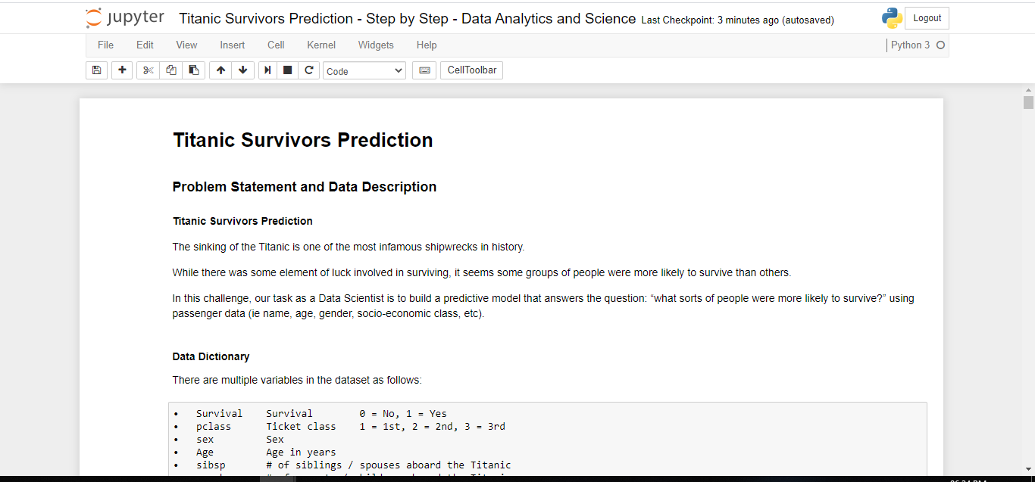

Loading and Setting up the Dataset:
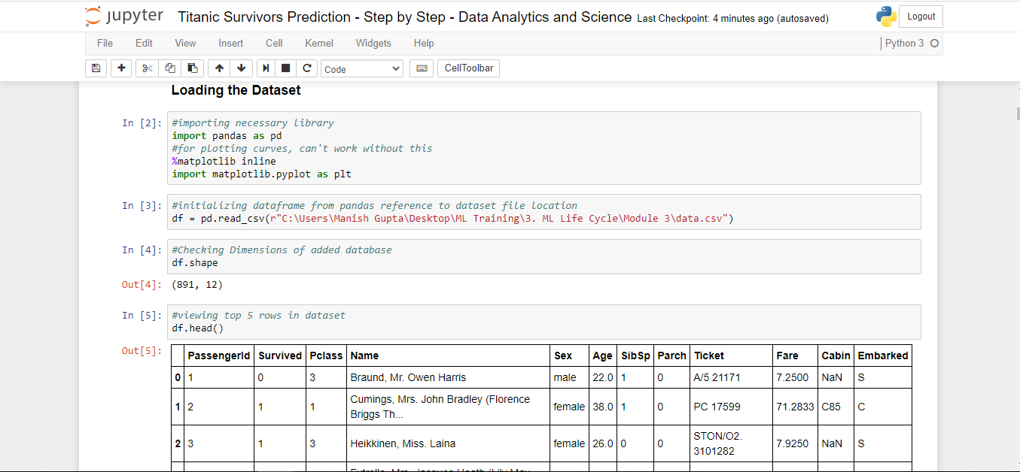

Analysis and Exploration of the Dataset:
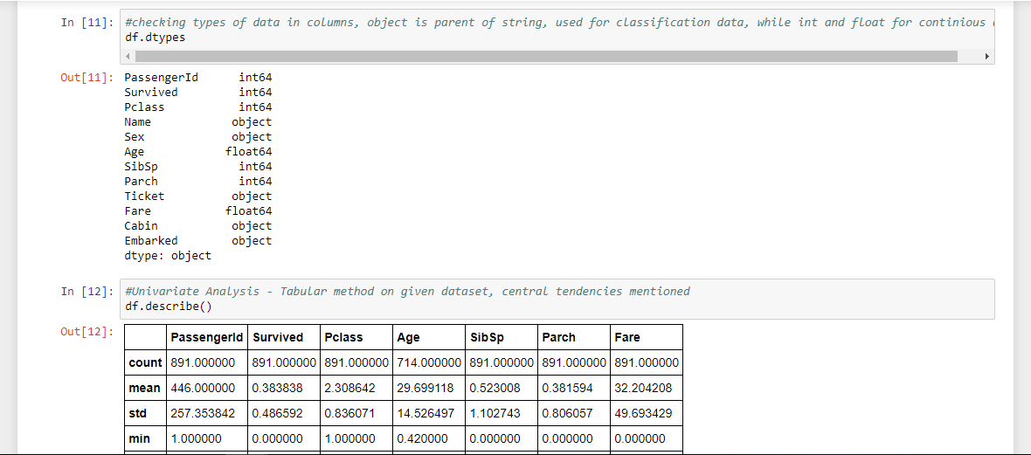
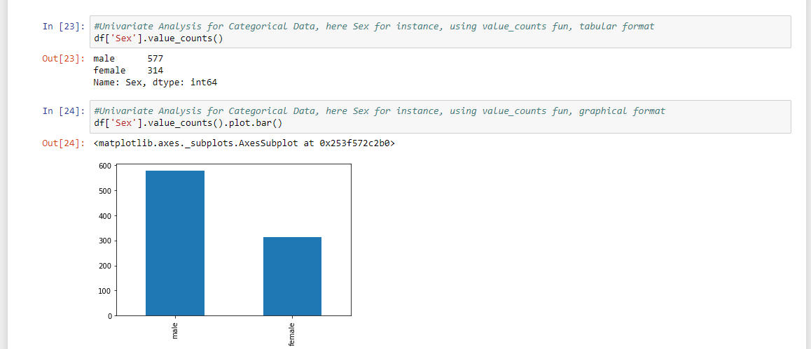
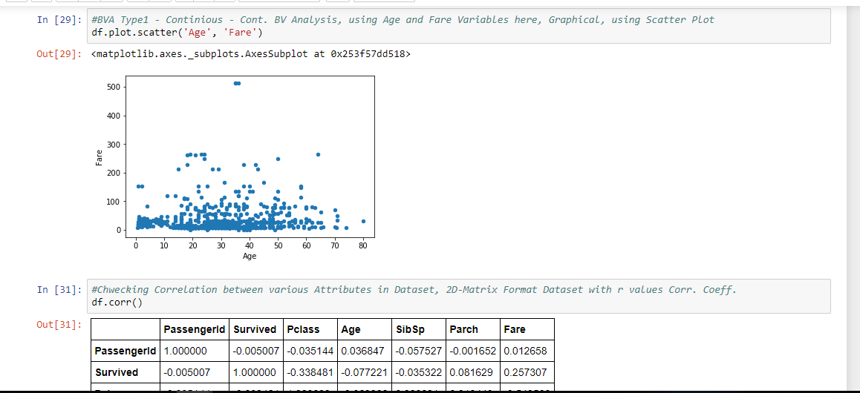
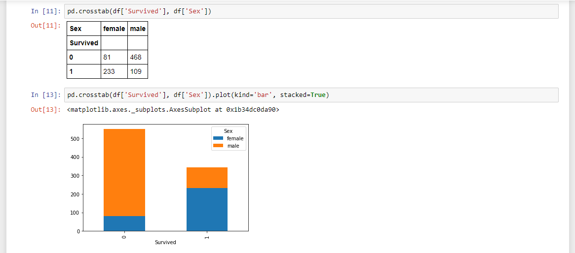

Cleaning Dataset and Building Model using Logistic Regression Algorithm:
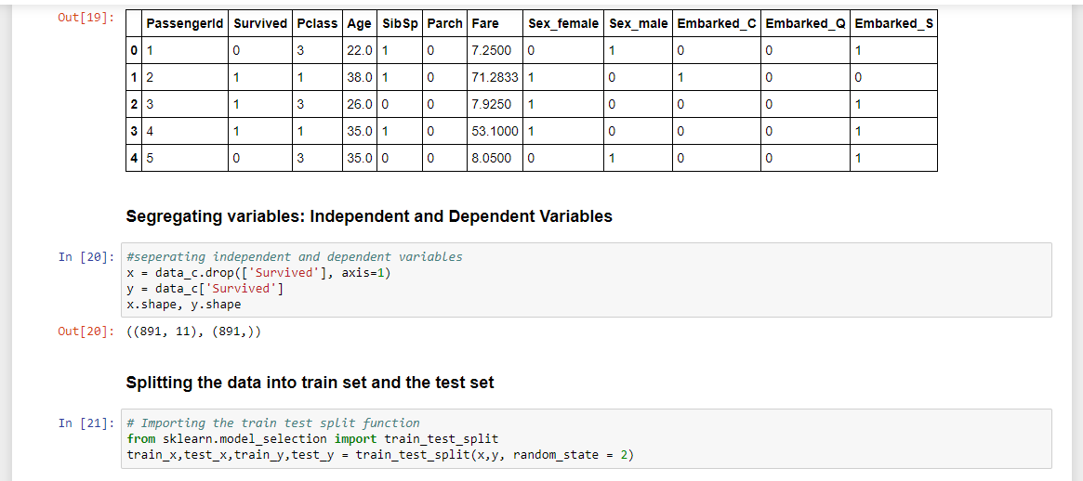
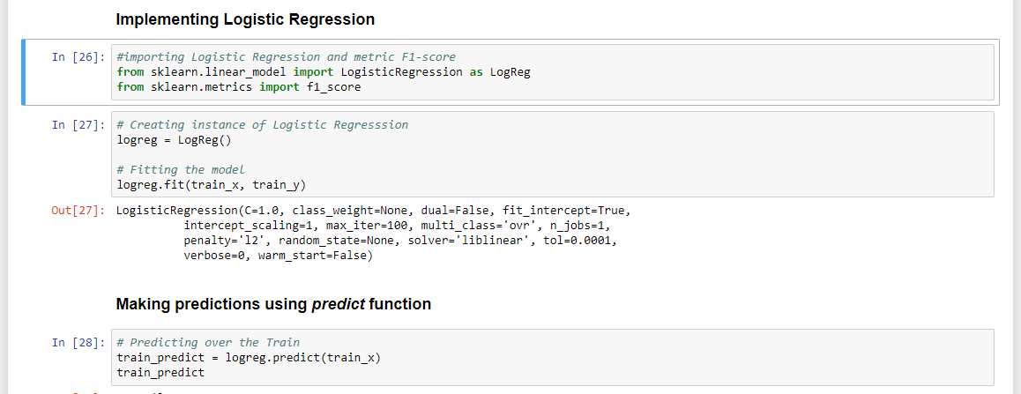
Checking Model Accuracy and Exporting Predictions Dataset:
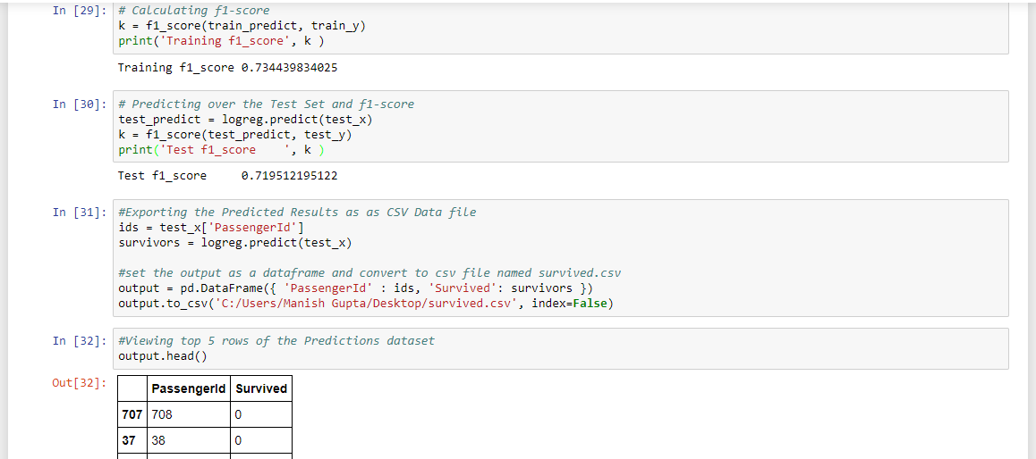

End of Project Report


